

Semester Two Examination, 2017

Question/Answer booklet

MATHEMATICS

SOLUTIONS
METHODS
UNITS 1 AND 2

Section Two:

Calculator-assumed

Student Number: In figures

In words

Your name

Time allowed for this section
Reading time before commencing work: ten minutes
Working time: one hundred minutes

Materials required/recommended for this section
To be provided by the supervisor
This Question/Answer booklet
Formula sheet (retained from Section One)

To be provided by the candidate
Standard items: pens (blue/black preferred), pencils (including coloured), sharpener, correction fluid/tape, eraser, ruler, highlighters

Special items: drawing instruments, templates, notes on two unfolded sheets of A4 paper, and up to three calculators approved for use in this examination

Important note to candidates
No other items may be taken into the examination room. It is your responsibility to ensure that you do not have any unauthorised material. If you have any unauthorised material with you, hand it to the supervisor before reading any further.

Structure of this paper

Section | Number of questions available | Number of questions to be answered | Working  time (minutes) | Marks available | Percentage of examination
Section One:  Calculator-free | 8 | 8 | 50 | 52 | 35
Section Two:  Calculator-assumed | 13 | 13 | 100 | 98 | 65
 |  |  |  | Total | 100

Instructions to candidates

1. The rules for the conduct of examinations are detailed in the school handbook. Sitting this examination implies that you agree to abide by these rules.

2. Write your answers in this Question/Answer booklet.

3. You must be careful to confine your response to the specific question asked and to follow any instructions that are specified to a particular question.

4. Additional working space pages at the end of this Question/Answer booklet are for planning or continuing an answer. If you use these pages, indicate at the original answer, the page number it is planned/continued on and write the question number being planned/continued on the additional working space page.

5. Show all your working clearly. Your working should be in sufficient detail to allow your answers to be checked readily and for marks to be awarded for reasoning. Incorrect answers given without supporting reasoning cannot be allocated any marks. For any question or part question worth more than two marks, valid working or justification is required to receive full marks. If you repeat any question, ensure that you cancel the answer you do not wish to have marked.

6. It is recommended that you do not use pencil, except in diagrams.

7. The Formula sheet is not to be handed in with your Question/Answer booklet.

Section Two: Calculator-assumed 65% (98 Marks)
This section has thirteen (13) questions. Answer all questions. Write your answers in the spaces provided.

Working time: 100 minutes.

Question 9 (6 marks)
(a) The tangent to the curve $y=16+2x-{2x}^{2}$ at $(2, 12)$ intersects the $x$-axis at $(a, 0)$. Determine the value of $a$. (3 marks)
Solution
$$\frac{dy}{dx}=2-4x=2-4\left(2\right)=-6$$

$$y-12=-6\left(x-2\right) \text{or} y=-6x+24$$

$$y=0⇒x=a=4$$

Specific behaviours
determines gradient of tangent
writes equation of tangent
states value of $a$

(b) If $f^{'}\left(x\right)=3x-x^{3}-1$ and $f\left(3\right)=0$, determine $f(1)$. (3 marks)

Solution
$$f\left(x\right)=\frac{{3x}^{2}}{2}-\frac{x^{4}}{4}-x+c$$

$$f\left(3\right)=0⇒c=\frac{39}{4}$$

$$f\left(1\right)=10$$

Specific behaviours
antidifferentiates
determines constant
states value

Question 10 (6 marks)
Line $L_{1}$ has equation $5x-2y=20$.

(a) Sketch the graph of $L_{1}$. (2 marks)

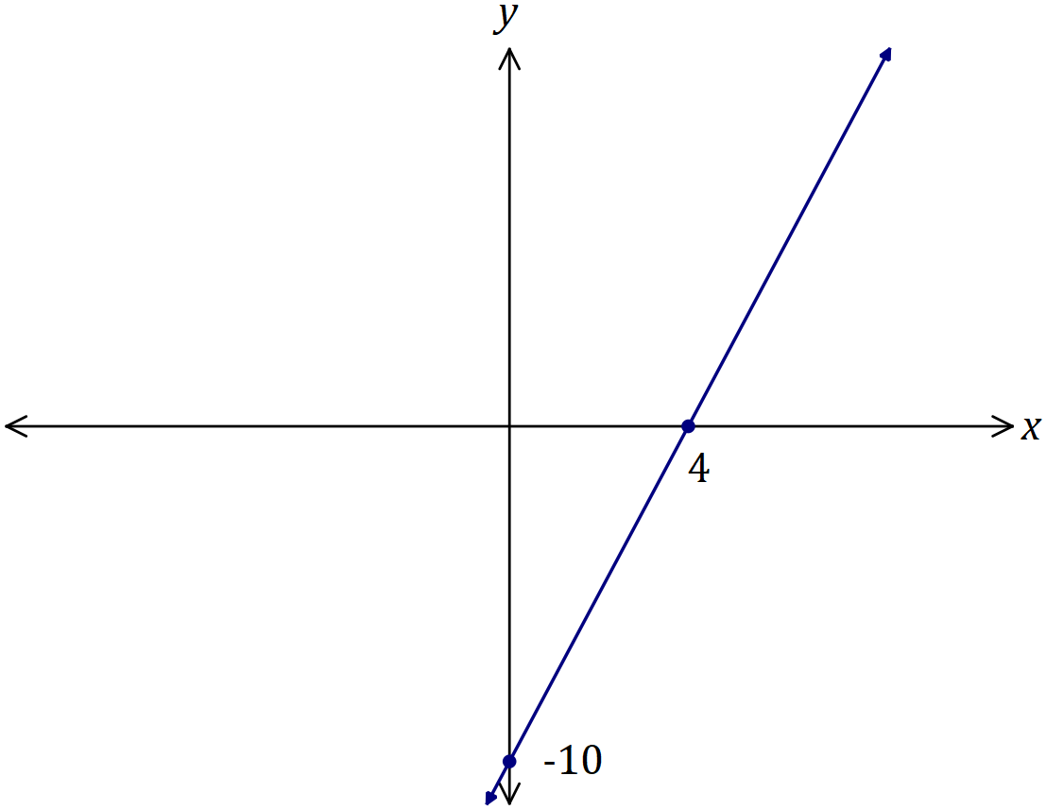
Solution
See graph
Specific behaviours
labelled intercepts
straight line

(b) Determine the equation of line $L_{2}$ that is parallel to $L_{1}$ and passes through the point with coordinates $(-3, -11)$. (2 marks)
Solution
$$5\left(-3\right)-2\left(-11\right)=-15+22=7$$

$$5x-2y=5 \left(\text{or} y=\frac{5}{2}x-\frac{7}{2}\right)$$

Specific behaviours
uses correct gradient
states equation

(c) Determine the equation of line $L_{3}$ that is perpendicular to $L_{1}$ and has the same $y$-intercept as $L_{1}$. (2 marks)
Solution
$$2x+5y=k$$

$$2\left(0\right)+5\left(-10\right)=-50$$

$$2x+5y=-50 \left(\text{or} y=-\frac{2}{5}x-10\right)$$

Specific behaviours
uses correct gradient
states equation

Question 11 (8 marks)
A group of 240 students were asked whether they had bought a drink or a snack from the school canteen. 72 had bought neither, 128 had bought a snack and 48 had bought both.

(a) Determine the number of students who only bought a drink. (2 marks)
Solution
$$n\left(D∪S\right)=240-72=168$$

$$n\left(D∩\overline{S}\right)=168-128 \\ =40$$

Specific behaviours
Venn diagram or other method
correct number

(b) Determine the probability that a randomly chosen student from the group had bought

(i) a snack or a drink. (1 mark)
Solution
$$P=\frac{168}{240}=\frac{7}{10}$$

Specific behaviours
correct probability

(ii) only a snack. (1 mark)
Solution
$$P=\frac{128-48}{180}=\frac{80}{240}=\frac{1}{3}$$

Specific behaviours
correct probability

(iii) a snack given that they had bought a drink. (2 marks)
Solution
$$P=\frac{48}{48+40}=\frac{48}{88}=\frac{6}{11}$$

Specific behaviours
uses conditional probability
correct probability

(c) For this group of students, are the events buying a snack and buying a drink independent? Justify your answer. (2 marks)
Solution
$P\left(S\right)=\frac{128}{240}=\frac{8}{15}$ and $P\left(S | D\right)=\frac{6}{11}$ and so $P\left(S\right)≠P(S|D)$ and so events are NOT independent.

Specific behaviours
uses probabilities
correct conclusion

Question 12 (6 marks)
The quadratic function $f\left(x\right)=ax^{2}+bx+c$ passes through $P(5, 9)$ and has roots at $x=-4$ and $x=7$.

(a) Determine the values of the constants $a$, $b$ and $c$. (3 marks)
Solution
$$f\left(x\right)=a\left(x+4\right)\left(x-7\right)$$

$$f\left(5\right)=9=a\left(9\right)\left(-2\right)$$
$$a=-\frac{1}{2}$$

$$f\left(x\right)=-\frac{1}{2}\left(x+4\right)\left(x-7\right)$$
$$=-\frac{1}{2}x^{2}+\frac{3x}{2}+14$$

$$a=-\frac{1}{2}=-0.5, b=\frac{3}{2}=1.5, c=14$$

Specific behaviours
writes in factored form
uses given point to determine $a$
expands and clearly states all values

(b) State the location of the $y$-intercept of the graph $y=-3f(x)$. (1 mark)
Solution
$$y=-3\left(14\right)=-42$$

Specific behaviours
correct $y$-value

(c) State the location of the roots of the graph $y=f(4x)$. (2 marks)
Solution
$$x=\frac{1}{4}\left(-4\right)=-1$$

$$x=\frac{1}{4}\left(7\right)=\frac{7}{4}=1.75$$

Specific behaviours
uses correct horizontal dilation
correct $x$-values

Question 13 (8 marks)
The number of followers of a social media influencer, counted at the start of five successive months, is shown in the exponential graph below.

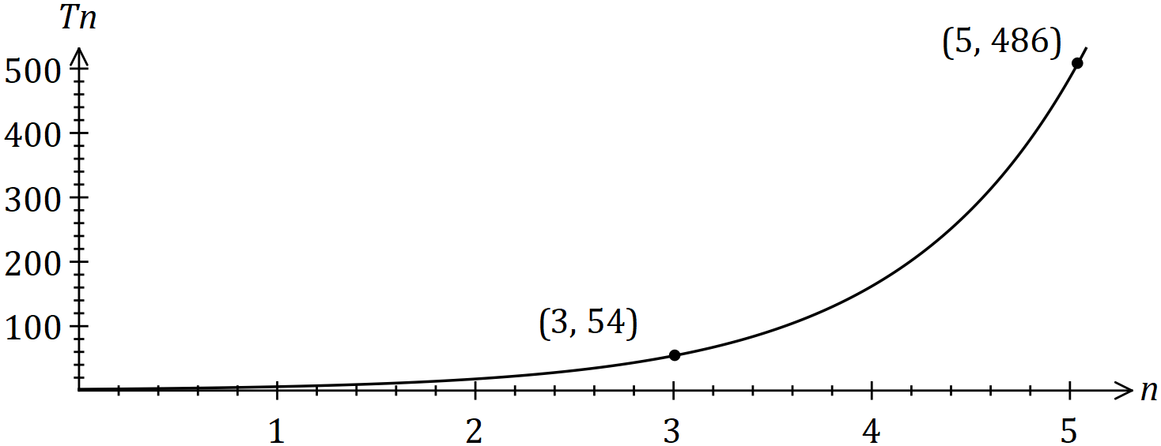

The number of followers ($T_{n}$) at the start of month $n$ can be modelled by the recursive equation $T_{n+1}=rT_{n} , T_{1}=a$.

(a) Use the graph to determine the values of $r$ and $a$. (3 marks)
Solution
$$r^{2}=486÷54=9⇒r=3$$
$$a=T_{3}÷3^{2}=6$$
Specific behaviours
equation using $r^{2}$
states $r$
states $a$

(b) Assuming the growth rate continues,

(i) how many followers are expected at the start of month 8? (1 mark)
Solution
$$T_{8}=13122$$
Specific behaviours
states number

(ii) at the start of which month will the number of followers first exceed 1 million?
(1 mark)
Solution
$$T_{n}={10}^{6}⇒n=11.9⇒\text{Start of month} 12$$
Specific behaviours
states month

(c) When the number of followers reached 2 million, the influencer fell out of favour and started to lose 40% of their followers each month. After how many months from this time will they have less than 1 000 followers? (3 marks)
Solution
$$T_{n}=2000000{\left(0.6\right)}^{n}$$

$$1000=2000000{\left(0.6\right)}^{n}$$
$$n=14.88$$

$$\text{After} 15 \text{months}$$

Specific behaviours
forms equation for nth term
solves equation
rounds correctly

Question 14 (7 marks)
(a) The graphs of $y=a\cos{x}$, $y=sin⁡(bx)$ and $y=\tan{(x+c)}$ are shown below.

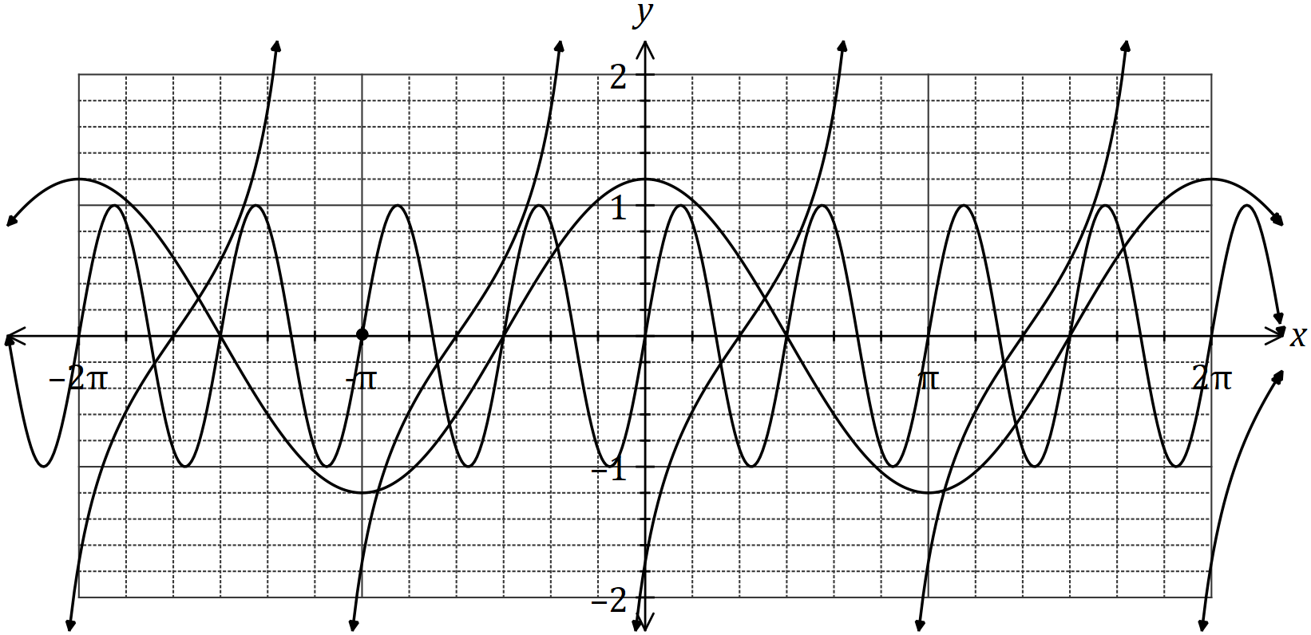

Determine the values of the constants $a$ and $b$ and the smallest positive value of the constant $c$. (3 marks)
Solution
$$a=1.2, b=4, c=\frac{2π}{3}$$

Specific behaviours
value of $a$
value of $b$
value of $c$

(b) One day, the depth of water in a tidal basin was modelled by $d=5.5+3.7\sin{(0.5t-0.6)}$, where $d$ was the depth in metres and $t$ was the time, in hours, after midnight. For this day, determine

(i) the depth of water at 9.30 am. (2 marks)
Solution
$$9.30 \text{am}⇒t=9.5$$
$$d\left(9.5\right)=2.37 \text{m}$$

Specific behaviours
converts time
determines depth

(ii) the last time that the depth of water was 8.3 m. (2 marks)
Solution
$$5.5+3.7\sin\left(0.5t-0.6\right)=8.3$$

$$\text{Using CAS}:t=18.33 \text{h}, \text{or 6.20 pm}$$

Specific behaviours
writes equation
solves equation over stated domain

Question 15 (8 marks)
A particle is moving along a straight line so that its displacement, $x$ metres, from a fixed point $O$ after $t$ seconds is given by
$$x=5-\frac{18t}{5}+\frac{12t^{2}}{5}-\frac{2t^{3}}{5} .$$

(a) Sketch the displacement of the particle on the axes below for $0≤t≤5$. (3 marks)

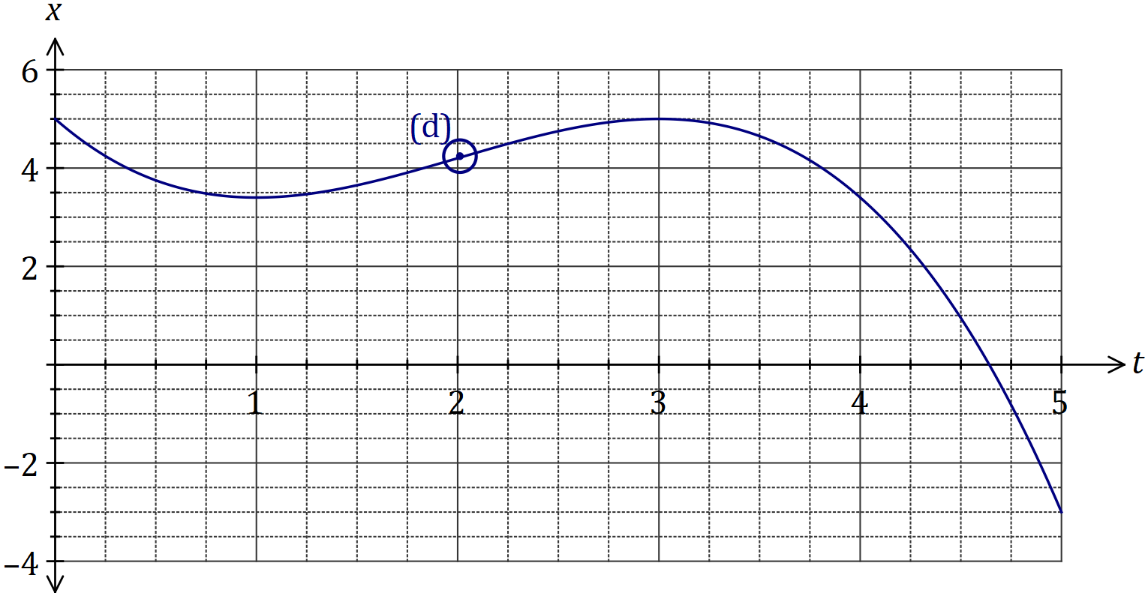
Solution (a)
See graph
Specific behaviours
through (0, 5) & (5, -3)
turning points located correctly
smooth curve

(b) Determine the velocity of the particle when $t=0.5$. (2 marks)
Solution
$$v=\frac{-(6t^{2}-24t+18)}{5}$$

$$v\left(0.5\right)=-\frac{3}{2}=-1.5 \text{m/s}$$

Specific behaviours
differentiates displacement
states velocity

(c) For how long during the first five seconds is the particle is moving towards $O$? (1 mark)
Solution
3.6 seconds (for $0<t<1$ and $3<t<4.6$).

Specific behaviours
correct time

(d) Circle the point on the graph where the particle is moving with the maximum velocity and explain what feature of the graph you used to choose this point. (2 marks)
Solution
See graph. Velocity is maximum at point where curve has greatest positive slope.

Specific behaviours
indicates point of inflection
explanation

Question 16 (8 marks)
The graph of $y=a^{x}$ is shown below, where $a$ is a positive constant.

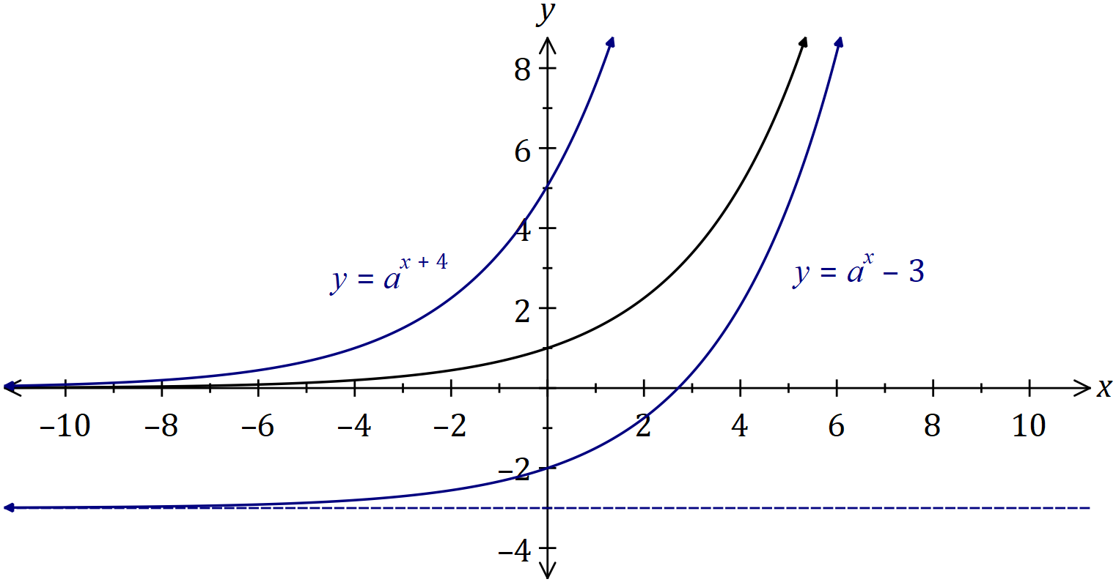

(a) On the same axes, sketch and label the graphs of

(i) $y=a^{x+4}$. (2 marks)
Solution
See graph
Specific behaviours
(i) y-int close to (0, 5); touches x-axis close to (-10, 0)
(ii) y-int at (0, -2); clear asymptote at $y=-3$

(ii) $y=a^{x}-3$. (2 marks)

(b) The graph of $y=a^{x+5}$ intersects the graph of $y={0.6}^{x}$ when $x=-2.2.$

Determine, giving your answers to 3 significant figures,

(i) the $y$-coordinate of the point of intersection. (1 mark)
Solution
$$y={0.6}^{-2.2}$$
$$=3.07657…$$
$$≈3.08 (3\text{sf})$$

Specific behaviours
value that rounds to 3.08

(ii) the value of the constant $a$. (3 marks)
Solution
$$a^{-2.2+5}={0.6}^{-2.2}$$
$$a=1.493859…$$
$$a≈1.49 \left(\text{3sf}\right)$$

Specific behaviours
writes equation
writes solution to equation
rounds answers to (b)(i) & (ii) correctly

Question 17 (6 marks)
(a) The variables $x$ and $y$ are related by ${\left(x+3\right)}^{2}+{\left(y+4\right)}^{2}=25$.

(i) Sketch the graph of this relationship. (3 marks)

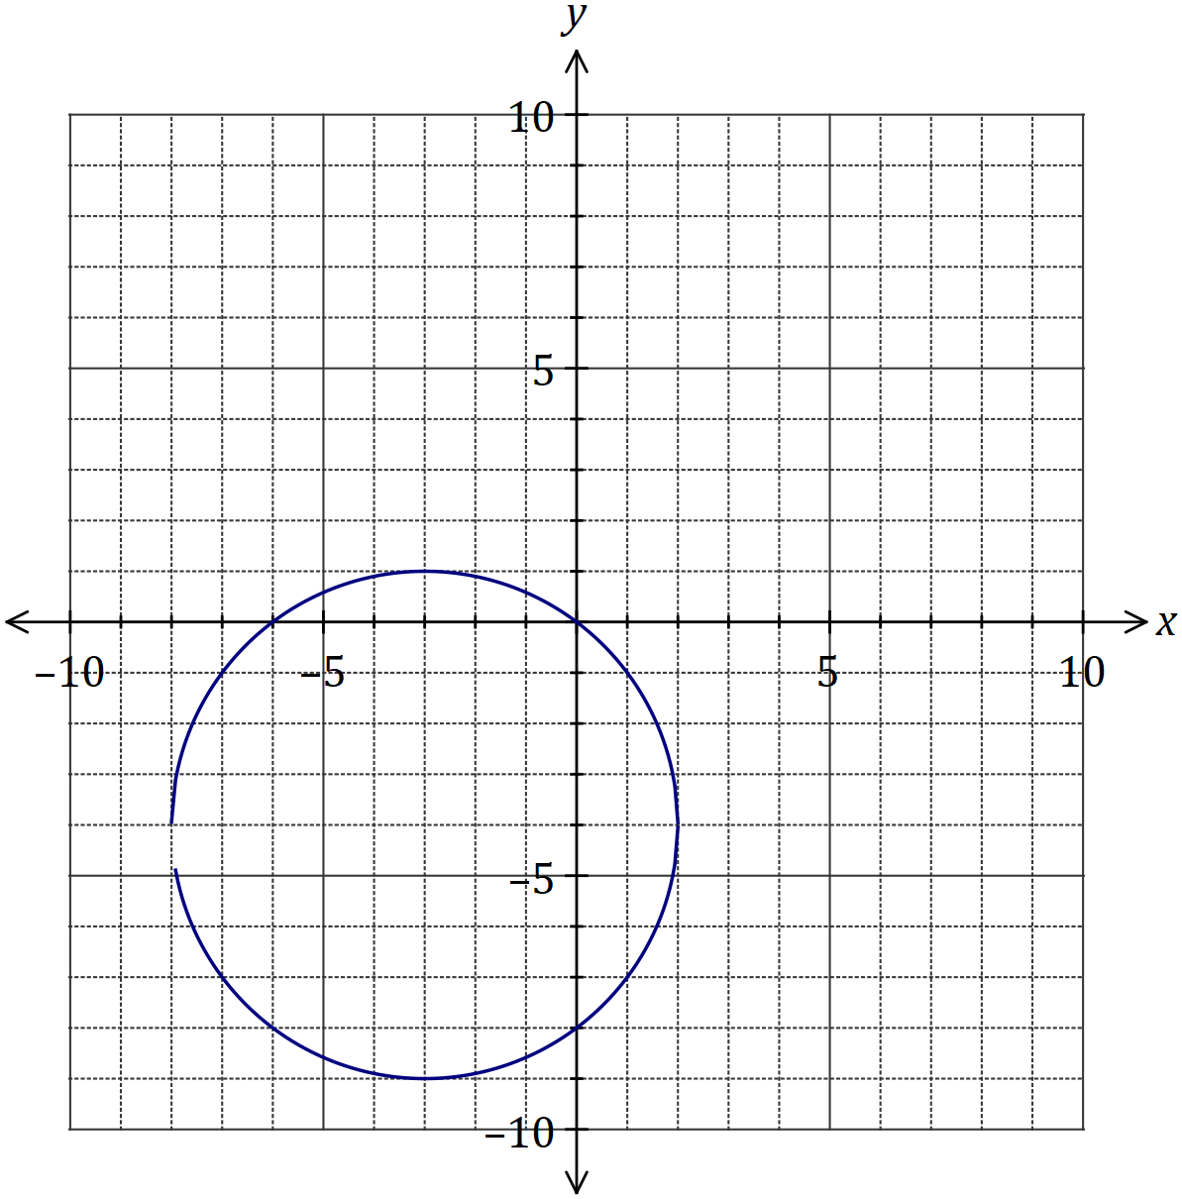
Solution
See graph
Specific behaviours
correct centre and radius
all axes intercepts
smooth curve

(ii) How does the vertical line test indicate that $y$ is not a function of $x$? (1 mark)
Solution
Any vertical line drawn between $-8<x<2$ will cut the graph more than once.

Specific behaviours
explanation

(b) State the domain and range of the function $f\left(x\right)=3-\sqrt{x-6}$. (2 marks)

Solution
$$D_{f}=\left\{x:x∈R, x≥6\right\}$$

$$R_{f}=\left\{y:y∈R, y≤3\right\}$$

Specific behaviours
indicates restriction on $x$ values
indicates restriction on $y$ values

Question 18 (11 marks)
Two circles of radii 13 cm and 18 cm have centres at $A$ and $B$ respectively. The centres are 9 cm apart and the circles intersect at $P$ and $Q$.

(a) Sketch a diagram of the two circles and clearly show triangle $ABP$. (2 marks)

Solution
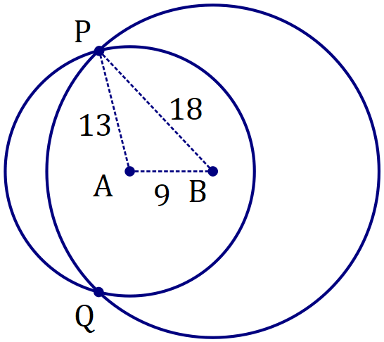
Specific behaviours
sketch showing $A, B, P \& Q$
shows triangle $ABP$

(b) Show that $∠PBA=43.2°$, when rounded to one decimal place. (2 marks)
Solution
$$\cos{B}=\frac{9^{2}+{18}^{2}-{13}^{2}}{2\left(9\right)\left(18\right)} \\ ∠PBA=43.248 \\ =43.2° \text{(1dp)}$$

Specific behaviours
substitutes correctly into cosine rule
states angle to 2 or more dp then rounds

(c) Determine the length of the chord $PQ$ to the nearest millimetre. (2 marks)
Solution
$$\frac{1}{2}PQ=18\sin{43.2°}$$

$$PQ=24.6 \text{cm}$$

Specific behaviours
uses right-angled trig
states length, rounded to nearest mm

(d) Determine the area common to both circles. (5 marks)

Solution
Segment, centre $B$:
$$\text{Angle}:2×43.2×\frac{π}{180}=1.509$$
$$A=\frac{1}{2}{\left(18\right)}^{2}\left(1.509-\sin\left(1.509\right)\right)=82.86$$

Segment, centre $A$:
$$∠PAB=108.44°$$
$$\text{Angle}:2×108.44×\frac{π}{180}=3.785$$
$$A=\frac{1}{2}{\left(13\right)}^{2}\left(3.785-\sin\left(3.785\right)\right)=370.54$$

Total:
$$A=82.86+370.54=453.4 {\text{cm}}^{2}$$

Specific behaviours
uses segment formula with angles in radians
states area of segment, centre $B$
shows $∠PAB$
states area of segment, centre $A$
correct total area

Question 19 (8 marks)
A composite solid is made from a cone and a cylinder, both of height $h$ cm and radius $r$ cm, as shown below.
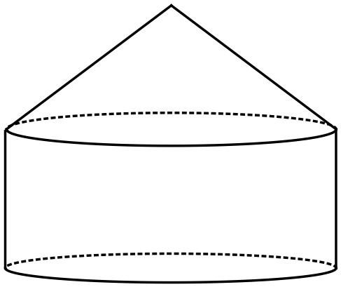

The dimensions are such that the sum of $h$ and $3r$ is $36$ cm.

(a) Show that the volume of the solid is given by $V=48πr^{2}-4πr^{3}$. (3 marks)
Solution
$$h+3r=36⇒h=36-3r$$
$$V=\frac{1}{3}πr^{2}h+πr^{2}h \\ =\frac{4}{3}πr^{2}h \\ =\frac{4}{3}πr^{2}\left(36-3r\right) \\ =48πr^{2}-4πr^{3}$$

Specific behaviours
writes $h$ in terms of $r$
substitutes into sum of cone and cylinder volumes
simplifies

(b) Use differentiation to determine the values of $r$ and $h$ that will maximise the volume of the solid, and state this maximum volume. (5 marks)
Solution
$$\frac{dV}{dr}=96πr-12πr^{2} \\ =0 \text{when} r=0, 8$$

$$\text{Optimum value of} r=8 \text{cm}$$

$$h=36-3\left(8\right)=12 \text{cm}$$

$$V\left(8\right)=1024π{\text{ cm}}^{3} (≈3217)$$

Specific behaviours
differentiates
determines root of derivative
states optimum value of $r$
calculates height $h$
calculates volume $V$

Question 20 (8 marks)
Events $A$ and $B$ occur at random and it is known that $P\left(B\right)=0.6$ and $P\left(A∪B\right)=0.72$.

(a) Determine $P(A)$ when

(i) $A$ and $B$ are mutually exclusive. (1 mark)
Solution
$$P\left(A\right)=0.72-0.6=0.12$$

Specific behaviours
states probability

(ii) $P\left(\overline{A}∩B\right)=0.55$. (1 mark)
Solution
$$P\left(A\right)=P\left(A∪B\right)-P\left(\overline{A}∩B\right) \\ =0.72-0.55 \\ =0.17$$

Specific behaviours
uses probability laws
states probability

(iii) $A$ and $B$ are independent. (3 marks)
Solution
$$\text{Let} P\left(A∩B\right)=x \text{and} P\left(A\right)×P\left(B\right)=P\left(A∩B\right)$$
$$\left(0.12+x\right)×0.6=x$$
$$x=0.18$$
$$P\left(A\right)=0.12+0.18=0.3$$

Specific behaviours
uses probability law for independence
determines $P\left(A∩B\right)$
states probability

(b) Determine $P\left(B|A\right)$ if $P\left(B|\overline{A}\right)=0.65$. (3 marks)
Solution
$$\text{Let} P\left(\overline{A}∩B\right)=x \text{and} P\left(\overline{A∪B}\right)=0.28$$
$$\frac{x}{x+0.28}=0.65$$
$$x=0.52$$

$$P\left(A∩B\right)=0.6-0.52=0.08$$

$$P\left(B | A\right)=\frac{0.08}{0.12+0.08}=\frac{0.08}{0.2}=0.4$$

Specific behaviours
determines $P\left(\overline{A}∩B\right)$
determines $P\left(A∩B\right)$
states probability

Question 21 (8 marks)
Seven different letters are selected from the thirteen in the word TROUBLEMAKING. The order in which the letters are selected is not important, so that the selection TROUBLE is the same as the selection OUBLERT, and so on.

(a) Determine the number of different selections

(i) of seven letters. (2 marks)
Solution
$$n=\left(\begin{matrix}13 \\ 7\end{matrix}\right)=1716$$

Specific behaviours
uses combination
correct number

(ii) of seven letters that contain one vowel and six consonants. (2 marks)
Solution
$$n=\left(\begin{matrix}5 \\ 1\end{matrix}\right)×\left(\begin{matrix}8 \\ 6\end{matrix}\right)=5×28=140$$

Specific behaviours
splits selections
multiplies selections

(b) Determine the probability that a random selection of seven different letters

(i) includes the letters T, R and O. (2 marks)
Solution
$$P=\frac{\left(\begin{matrix}3 \\ 3\end{matrix}\right)×\left(\begin{matrix}10 \\ 4\end{matrix}\right)}{1716}=\frac{210}{1716}=\frac{35}{286}≈0.1224$$

Specific behaviours
selects (i) M & A (ii) other four
states probability

(ii) includes at least one vowel. (2 marks)
Solution
$$P=1-\frac{\left(\begin{matrix}5 \\ 0\end{matrix}\right)×\left(\begin{matrix}8 \\ 7\end{matrix}\right)}{1716}=1-\frac{8}{1716}=\frac{1708}{1716}=\frac{427}{429}≈0.9953$$

Specific behaviours
selects no vowels
states probability

Additional working space

Question number: _________

Additional working space

Question number: _________

Additional working space

Question number: _________

© 2017 WA Exam Papers. Kennedy Baptist College has a non-exclusive licence to copy and communicate this document for non-commercial, educational use within the school. No other copying, communication or use is permitted without the express written permission of WA Exam Papers. SN245-102-4.

